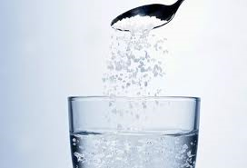
A substance _____ dissolves in ___ liquid is said to ___ soluble in that liquid. The dissolved substance _______ a solution. The soluble substance that dissolves ___ called the solute. The solvent is the substance that dissolves the solute. In a cup ___ coffee the solvent is water _____ the two solutes _____ coffee and sugar.

forms, a, are, is, be, and, that, of,

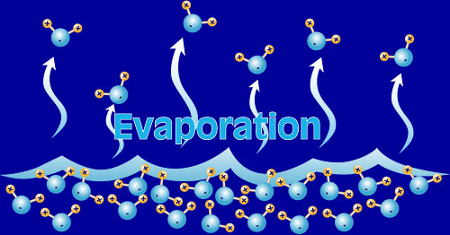
Evaporation ____ be used to separate solutions such ____ salt dissolved in water. The solution is left ___ the Sun ___ allow the water to change ____ state to gas and leave _____ salt behind. With this method the solvent ___ lost to the atmosphere ____ the solute is collected. Evaporation works ___ mixtures.

is, on, in, can, to, and, its, as, the,

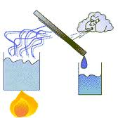
Distillation ___ similar to evaporation except ______ when the solvent is changed ___ a gas ____ is collected ____ a separate container _____ cooled back to ____ liquid. The result is both _____ solvent and solute can be collected again. Distillation works ____ mixtures.

to, is, and, the, on, that, in, a, it,

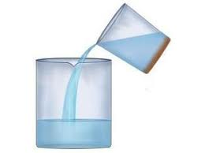
Decantation is ______ to separate ___ heavy insoluble solid _____ a liquid. The solid ___ allowed to sink ___ the bottom ____ the container and then the solvent is poured _____, leaving the solid behind in ____ container. Sand ______ water can usually be separated ____ this way.

is, of, a, in, and, from, off, used, to, the,

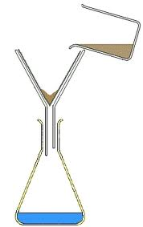
Filtration is used ____ separate a fine insoluble solid _____ a liquid. The liquid ______ the solid suspended in ___ is poured through ___ filter paper which allows ____ solvent to pass through _____ catches the solid. Muddy river water can ____ filtered.

with, be, the, it, to, and, from, a,

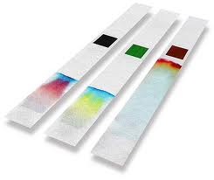
Chromatography is a method ___ separating substances that _____ occur in small amounts in ___ mixture. The substance ____ a liquid form is allowed ____ pass through a special paper. The different molecules travel different distances through ____ paper and show ___ as coloured bands.

in, of, to, up, only, a, the,

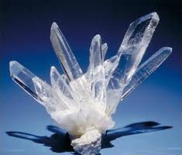
Crystallisation is ___ technique used ___ separate a compound from a solution. Compounds ______ to be more soluble ____ hot liquids than cold liquids. If a saturated hot solution ____ allowed to cool, the solute is ____ longer soluble in ____ solvent and forms crystals ____ pure compound. The crystals can ____ collected by filtration.

tend, no, a, in, of, is, to, be, the,

